Assessment 1 Report

# Implementation

For this section I will explain my code from top to bottom. Initially, I initialised variables containing the strings that the user will be prompted with. I also initialised variables called:

* loops – The number of loops to complete; defined when the user when prompted by: “How many numbers”.
* number – The number entered by the user when prompted by: “Enter a number”.
* positives – The counter for positive numbers.
* negatives – The counter for negative numbers.
* zeroes – The counter for zeroes.

The flow of execution is as follows:

1. First the program will print the contents of the string msgMany to the console and store the user’s input to loops.
2. loops will then be moved to ECX before starting the inputLoop label.
3. To avoid ECX getting poisoned by external functions ECX is pushed to the stack.
4. msgEnter will then be printed to the console and the user’s response saved to number.
5. number will then be compared to 0:
   1. If the comparison sets the zero flag, then execution will branch to addZero.
      1. addZero will load the zeroes variable into the accumulator, increment it, and then move the accumulator back to the zeroes variable.
   2. If the comparison set the sign flag, then execution will branch to addNegative.
      1. addNegative will load the negatives variable into the accumulator, increment it, and then move the accumulator back to the negatives variable.
   3. If none of those flags are set, then the execution falls through and the positives counter is incremented.
6. All branches jump to the back label.
7. The loop counter is popped from the stack and loops to step 3., or falls through, using loop.
8. The summary is printed by:
   1. Each message and value to be displayed is pushed to the stack interlaced with a loop counter.
      1. The loop counter is pre-set in the stack so that the loop counter doesn’t get in the way when calling printf later.
   2. msgBar is printed and the stack pointer incremented, by 1 word, to the next item.
   3. A loop is started to print all the messages and values from the stack. After the item is printed the stack pointer is incremented 2 words to reveal the loop counter.
      1. The loop counter is popped into ECX. Program flow loops to step 8c., or falls through, using loop.

# Testing

## Single Positive Input

### Input

|  |  |
| --- | --- |
| Iterations | 1 |
| Number(s) | 1 |

### Expected Output

|  |  |
| --- | --- |
| Positive | 1 |
| Negative | 0 |
| Zero | 0 |

### Program Output

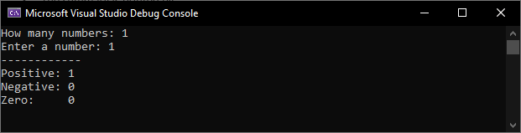

## Long Multi-Input

### Input

|  |  |
| --- | --- |
| Iterations | 11 |
| Number(s) | -5, -4, -3, -2, -1, 0, 1, 2, 3, 4, 5 |

### Expected Output

|  |  |
| --- | --- |
| Positive | 5 |
| Negative | 5 |
| Zero | 1 |

### Program Output

